Title | Digital Output Subsystem: Requirement Specification
Distribution | Software Archive
Author | Paul Li |  | Date | 2011-09-14
Review | Software Architect | R&D, D&D Instrumentation | Date
Approved |  |  | Date
Remarks | All Requirements will be implemented as defined in this document and tested accordingly.

Contents

1 Introduction 3
1.1 Scope 3
1.2 Definitions 4
1.3 Acronyms and Abbreviations 5
2 Overall description 6
3 Assumptions and dependencies 7
3.1 Assumptions 7
3.2 Dependencies 7
4 System / project related requirements 8
DO0: System / project requirements 8
5 Functional requirements 9
5.1 Digital Output Subsystem Requirements 9
DO1: General requirements 9
DO2: Null Output requirements 9
DO3: Logic Output requirements 10
DO4: Pulse Output requirements 10
DO5: Frequency Output requirements 11
5.2 Digital Outputs required hardware (M16C) capabilities 12
6 Digital Output Subsystem Documentation 12
7 References 13
8 Revision History 13

List of Figures

Figure 1: Flow Platform 3
Figure 2: Digital Output Subsystem Use Case Diagram 6

Introduction

Scope

This document is intended to specify the software requirements for the Digital Output Subsystem in detail. The Digital Output Subsystem is part of the Flow Platform shown in figure 1.
Figure 1: Flow Platform
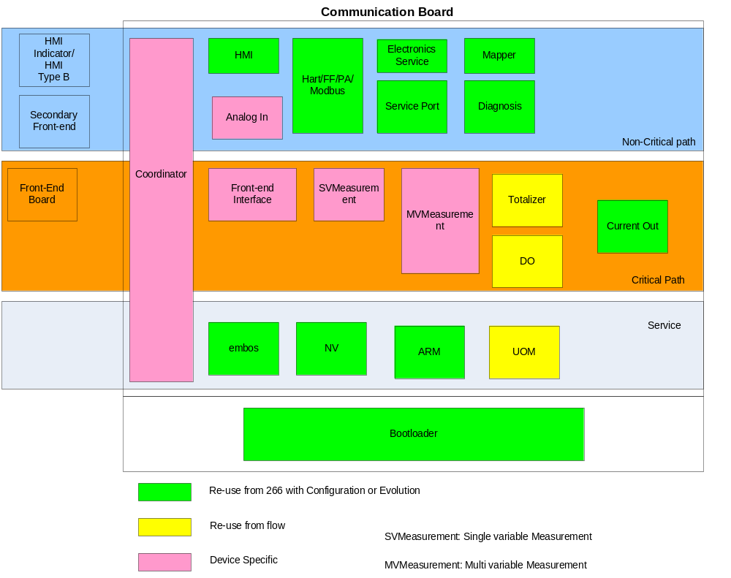

The Digital Output Subsystem design, implementation and black – box testing will be based on the requirements listed herein.

Definitions

Term | Definition
Diagnosis Subsystem | Subsystem responsible for handling error conditions and warnings.
Digital Output Subsystem | Subsystem for providing output signals (e.g. for pulse output, alarm/signal indication, etc.) to external hardware.
HART Subsystem | Subsystem responsible for interfacing to HART protocol communications.
PA Subsystem | Subsystem for interfacing to Profibus PA protocol communications.
FF Subsystem | Subsystem for interfacing to Foundation Fieldbus protocol communications.
HMI Subsystem | Subsystem providing HMI for local user access via display and key input.
Totalizer Subsystem | Subsystem for providing/maintaining flow mass / volume information to local user and other subsystems.
Units Subsystem | Subsystem responsible for holding units-of-measure setting(s), and providing the necessary conversion for other subsystems.

Acronyms and Abbreviations

DO | Digital Output
HART | Highway Addressable Remote Transducer
PA | Profibus PA
FF | Foundation Fieldbus
HMI | Human Machine Interface
NC | Normally Closed
NO | Normally Open
OP | Output
UOM | Units of measurement

Overall description

The Digital Output Subsystem is intended for delivering one digital signal for output on dedicated hardware port-lines. The signal-source for these digital outputs is derived from a HMI (also HART and PA/FF) supplied configuration. Briefly this can be a simple logic signal, or it can be a pulse-train representing the measured flow value or alternatively a frequency representing another process value.
For all other uses-cases, see Figure 1:

Figure 2: Digital Output Subsystem Use Case Diagram
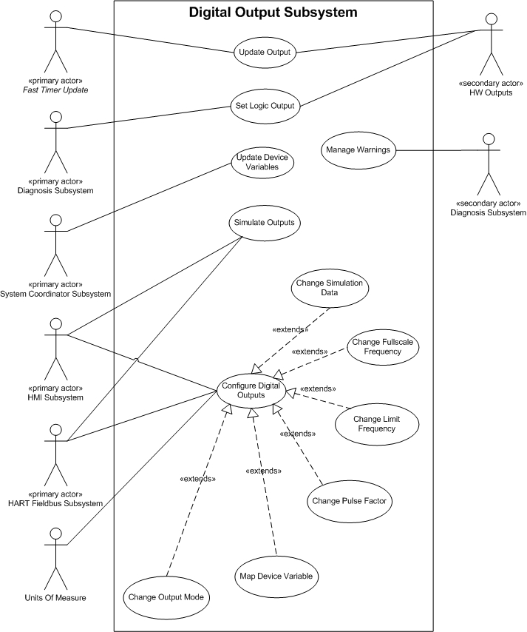

Assumptions and dependencies

Assumptions
- The Digital Output Subsystem will be triggered by the coordinator. Therefore it is assumed that triggers for the Digital Output Subsystem will be provided through interface methods in the Digital Output Subsystem and likewise the external subsystems will have to provide interface methods for the Digital Output Subsystem to use for passing result data out to them.
- External Subsystems (in that case the MVM Subsystem) will provide all device / output variables that should be readable by the Digital Output subsystem.
- Digital Output 1 can act as pulse-train or frequency output.

Dependencies
- The Digital Output Subsystem will be developed for 2 wire extended Communication Board.
- It is part of the 2 wire Platform, figure 1, which is in development.
- Development and testing will be done regarding to the following conditions:
  - Compiler: IAR Compiler V3. 50
  - Framework: 2.3.0
  - Oscillator frequency: 3.686 MHz
  - CPU clock is oscillator frequency / 2 (for VT5)
  - System update rate / execution time: VT5 100 ms
These conditions are chosen with respect to the low power design of the VT5. However, the subsystem has to be tested with all the conditions of the other projects.

System / project related requirements

The following requirements are related to the fact that the Digital Output subsystem should be programmed with most efficiency regarding to code size and execution time.

DO0: System / project requirements
Ident | Definition
DO0.1 | No compiler optimisations are permitted.
DO0.2 | Development and test of the Digital Output Subsystem has not to be done as a stand alone subsystem but in the Flow Platform project (which will be provided).
DO 0.5 | Code size for the Digital Output subsystem should not exceed 10 kByte.
DO 0.6 | Execution time for Digital Output update has to be equal or less than 8 ms with the conditions defined in chapter 3.2 for the VT5.
DO 0.7 | No T_UNIT-Methods (e.g. Put- and Get) should used during Fast-Path. This maybe result to multiple EXE-Methods.

Functional requirements

Digital Output Subsystem Requirements

DO1: General requirements
Ident | Definition
 | Digital Output Subsystem will support the following configurations:
DO1.1 | Digital Output 1 can be used as logical / binary outputs.
DO1.2 | Digital Output 1 can be set active high/low but only if logical output is used on OP1.
DO1.3 | Digital Output 1 can be set as pulse – output (only active high).
DO1.4 | Digital Output 1 can be set as frequency - output.
DO1.6 | Digital Output Subsystem will change, on command from an external user-interface (interface: HMI, HART, PA/FF), its operation mode. The Digital Output subsystem may be operated in Normal (Running), or Simulation (Function Test) mode. External subsystems will maintain a record of the current status and the result of any function test.
  Configuration | OP1
  Operation Mode | Normal / Simulation

DO2: Null Output requirements
Ident | Definition
 | Digital Output Subsystem will support the following general Digital Output configurations.
DO2.1 | No Function, i.e.: Digital Output function turned off. “Off” in this context means no signal source selected and the action state “NO” applied (as in “open contact”). External subsystems like HMI and HART, PA/FF could turn off/on the Digital Output.

DO3: Logic Output requirements
Ident | Definition
 | Digital Output Subsystem will support the following Logic Output configurations;
DO3.1 | One preselected alarm
DO3.2 | One preselected diagnosis
DO3.3 | One preselected NE 107 group
DO3.4 | Any diagnosis (including alarms) activates the Digital Output

DO4: Pulse Output requirements
Ident | Definition
 | Digital Output Subsystem will support the following Pulse Output functionality for Digital Output 1:
DO4.1 | Output a user-defined number of pulses regarding to a programmable unit (e.g. nm³, m³ and kg) (the Unit could be adjusted over the HMI or HART, PA/FF Subsystem). The input must be non-volatile selected out of the mass/ normal volume/ net mass/ net volume/ volume flow value from the MVMeasurement subsystemwhich supplies flows in base unit (Unit conversion will be done by the UOM.).  Precautions must be taken not to lose any pulses, such that totalization of the pulses output, ie: to an external counter, will show no variation with the internal Totalizer Subsystem.
DO4.2 | The pulse width can be chosen between 1 … 2000 ms.
DO4.3 | The pulse factor can be chosen between 0.001 – 1000 pulses.
DO4.4 | The full scale pulse frequency (equal to 100% Qmax) is 10000 Hz. It must be possible to output 105% of Qmax (10500 Hz).
DO4.5 | The unit of the pulse output should be chosen independently from the published totalizer unit. The unit conversion will be done by using the UOM Subsystem.

DO5: Frequency Output requirements
Ident | Definition
 | Digital Output Subsystem will support the following Frequency Output functionality for Digital Output 1:
DO5.1 | The subsystem outputs a user-defined frequency proportional to a Device Variable in percent regarding to its limits.  The inputs are mass flow, norm flow, volume flow, net mass flow, net volume flow, pressure and temperature from the MVMeasurement subsystem which supplies them in percent.
DO5.2 | The Digital Output Subsystem maps the chosen output value (chosen via HMI, HART or PA/FF) to the frequency output (Digital Output 1).
DO5.3 | The limit frequency (equal to 100% of mapped input value) can be chosen up to 10000 Hz. It must be possible to output 105% (max. of 10500 Hz).
DO5.4 | The maximum allowed frequency (irrespective of Qmax) is 10500 Hz. The minimum allowed frequency is 0.25 Hz.
DO5.5 | It should be possible to output a user-defined frequency for simulation.

Digital Outputs required hardware (M16C) capabilities

The Digital Output Subsystem requires the following hardware capabilities:

→ 3 Timers (Timer A0, A4 and B2) are required for pulse generation
→ 1 Port Pin is required for pulse and logical output
- Digital Output 1: Port Pin 8.0 is required for hardware timer A4

Digital Output Subsystem Documentation

The following documents have to be generated for the Digital Input Subsystem:
- Software Design Description including performance data
- Module Test Plan
- Module - Test document
- Performance Test document

References
Ref. | Document
[ ]
[ ]

Revision History
Rev. | Description of Version/Changes | Primary Author(s) | Date

